6 Functions

# What are Functions in SASS?

Functions in Sass are very similar to functions that are in JavaScript. So, if you are familiar with JavaScript, you should find this function stuff to be much easier to get the hang of.

# Creating your first SCSS function

Go to your **main.scss** file

We are going to be placing the functions right under our import statements on the page

@function weight($weight-name) {

    @return map-get($font-weights, $weight-name);

}

This will be simplifying some of our code, so it does not look so clucky.

Scroll down to where you wrote that nested code. We will be targeting this line of code.

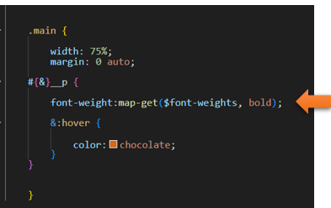

…and with our new function, we can change it to this: We also changed the code from bold to regular, but it is much simpler to write now.

 .main {

        width: 75%;

        margin: 0 auto;

    #{&}__p {

        font-weight:weight(regular);

        &:hover {

            color:chocolate;

        }

    }

    }

bold

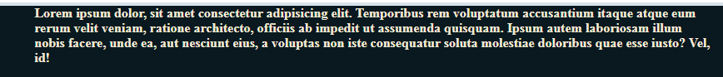

regular



<https://www.youtube.com/watch?v=_a5j7KoflTs>

